**The Power of Prayer as an EWTN Media Missionary**

**Testimony of Eugenia, from Canada**

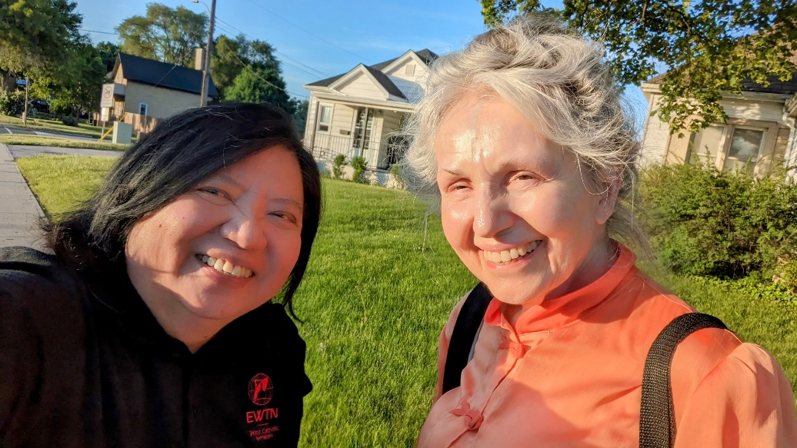

**Eugenia** volunteered to lead, mentor and encourage other local Media Missionaries in her area as an Area Coordinator Media Missionary. **She does not use a computer, has no email or even a car**... but still Eugenia evangelizes with EWTN! Nerissa, the EWTN Regional Manager of Canada, sat down with her and here is her story.

*Nerissa and Eugenia*

*Euginia, Media Missionary from Canada and Eugenia*

*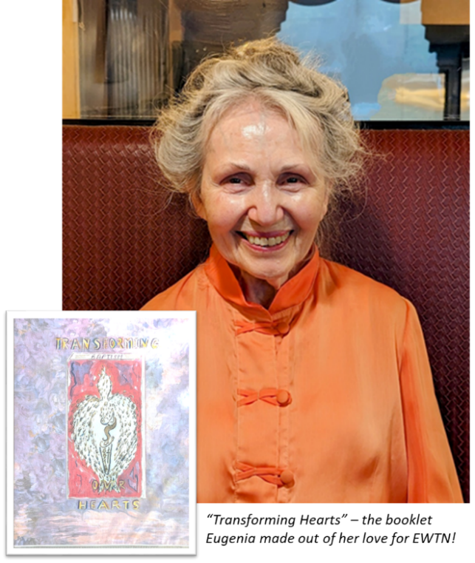“**As an EWTN Media Missionary, I realize I can help to bring people to their salvation. What could be more important than that? Nothing!”   
– MM Eugenia of Waterloo, Ontario, Canada*

I was in crisis with family challenges when my husband passed 35 years ago. Daily, on my way to my job at the hospital, I would visit a bakery where a friend worked. She told me about EWTN because she knew of my situation, *“you got to listen to EWTN, that will really help you!”*. So I would tune in to EWTN and it became my consolation and refuge from my loneliness and grief. The apologists on EWTN are deeply rooted in their love of the faith and in their knowledge of authentic Catholic teaching.

EWTN has so spiritually enriched me that I made a booklet entitled “Transforming Hearts”. It captured what I had heard on EWTN and I added my own reflections. I had 75 sets made and left these in various adoration chapels. I hope it brought people the same comfort, strength, consolation and faith that I got from EWTN.

I am now 84 and it is my mission to continue promoting EWTN to let people know how important faith is in our lives and to honor Jesus and the Blessed Sacrament. I love EWTN and if not for it, I would have ended up depressed and lonely. Doing my mission for EWTN is a source of daily joy!  
 *“If it wasn’t for EWTN I wouldn’t be as close to Jesus as I want to be and I wouldn’t be as kind to others.”*

*June 3, 2024 Media Missionary Office Article by Nerissa Flores*